CSCI-UA 476 001

Processing Big Data for Analytics Applications

Group 9: Aknur Kassym, Alex Ma, Aibar Talip

The effect of renewable energy development on carbon emissions

This document is dedicated to show the screenshots and results that have been obtained running the program using big data tools like Scala, HDFS, etc.

**Uploading the data into Hadoop**:

There are three datasets used in this project: *fossil_co2.csv*, *re_generation.csv*, *investment_data.csv*. All these 3 datasets have been uploaded to the dataproc HDFS, as can be seen in the screenshot below. More about the access to these datasets can be found in the Readme file.

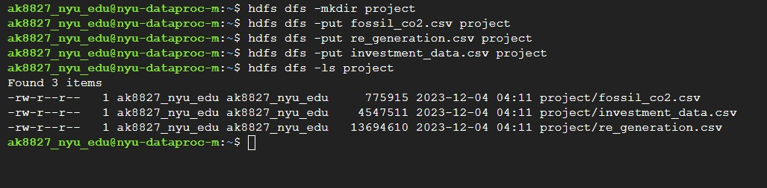

**Global, Regional, and National Fossil-Fuel CO2 Emissions: 1751-2017 (Aknur - ak8827)**

The dataset Displays global and national CO2 emissions from 1751, covering various fuels sources, including solid, liquid, gas, cement, etc.

1. Dataset loading and profiling

The dataset was first loaded from the HDFS using Scala and profiled to identify basic structure, schema, sample data, summary statistics, null and distinct values. As a result of profiling the data, certain problems were identified, which were then tackled at the cleaning stage later.

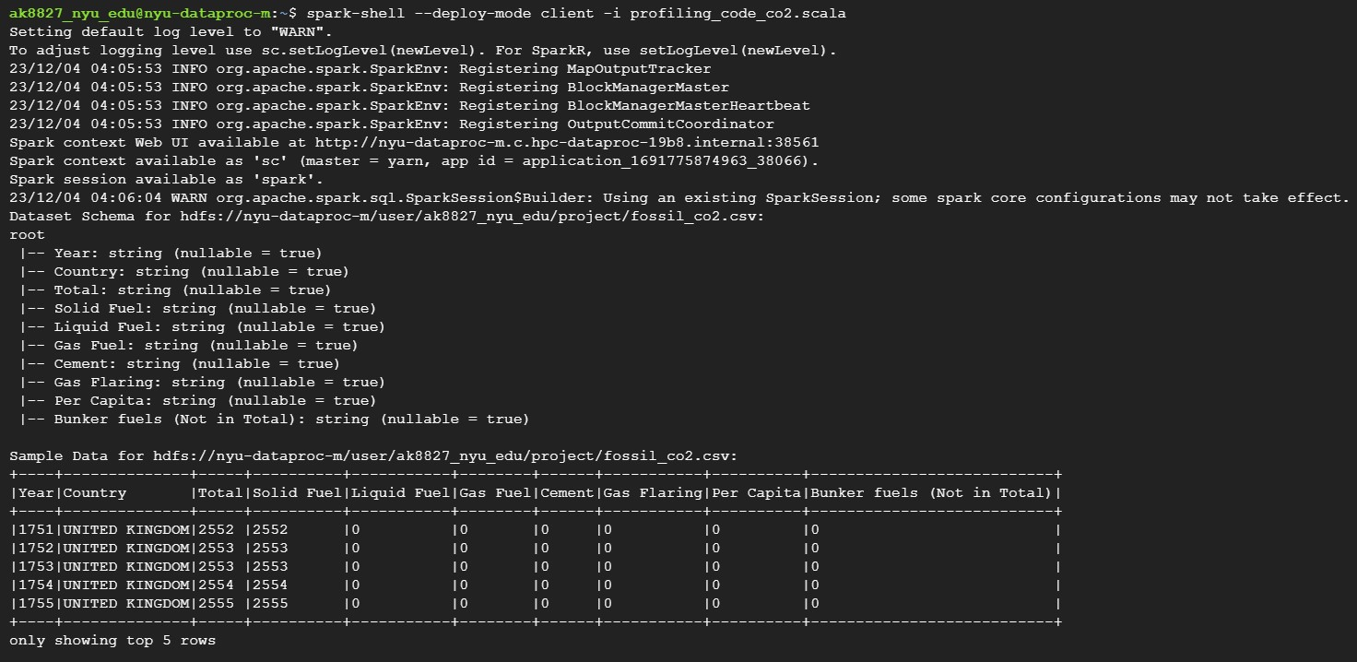

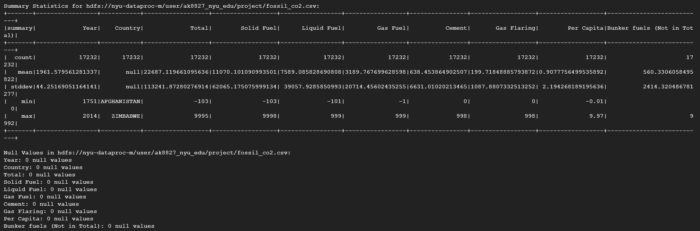

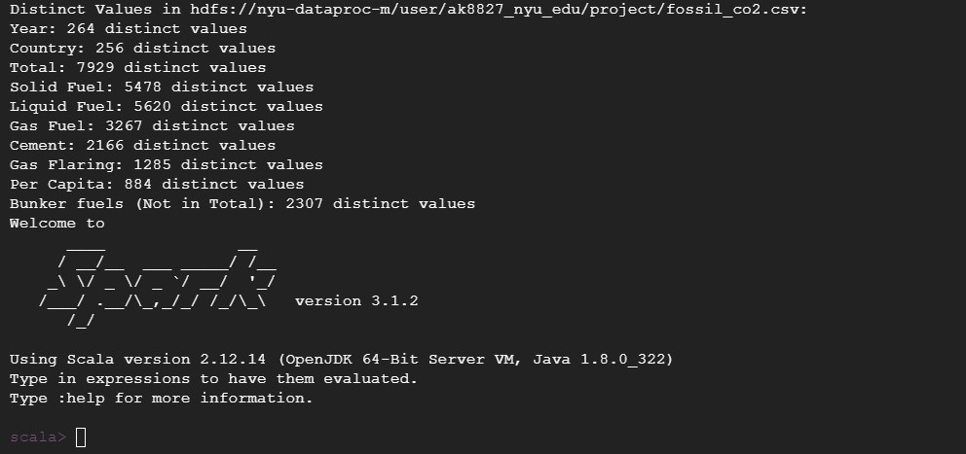

1. Data cleaning

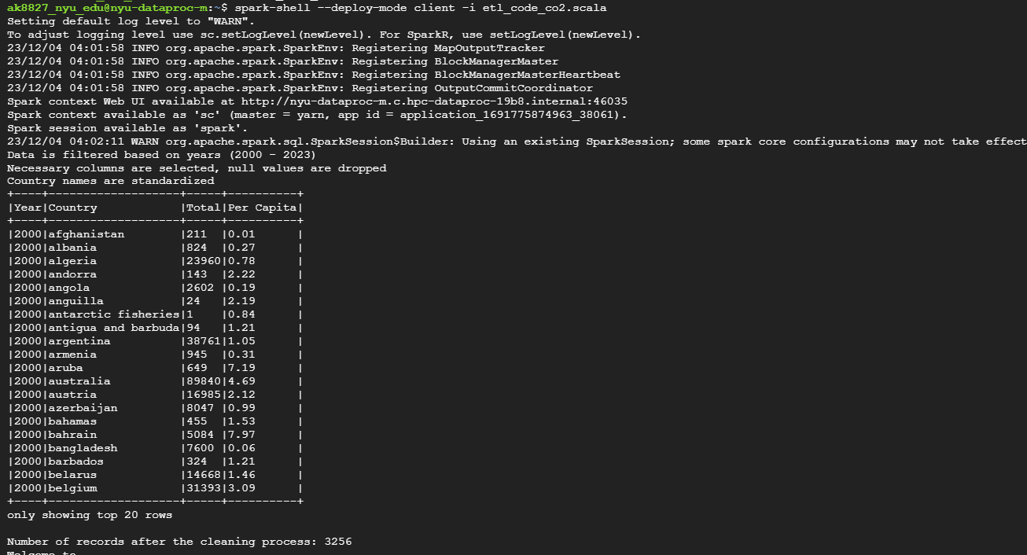

1. Analytics

There were 5 different analyses conducted:

1. Top 10 countries contributing to fossil-fuel CO2 emissions
2. Top 10 countries with the lowest fossil-fuel CO2 emissions
3. Cumulative CO2 emissions for each year across all countries
4. Linear regression to identify countries with the biggest spike in emissions over the years
5. Correlation between fossil fuel CO2 emissions and Renewable energy generation

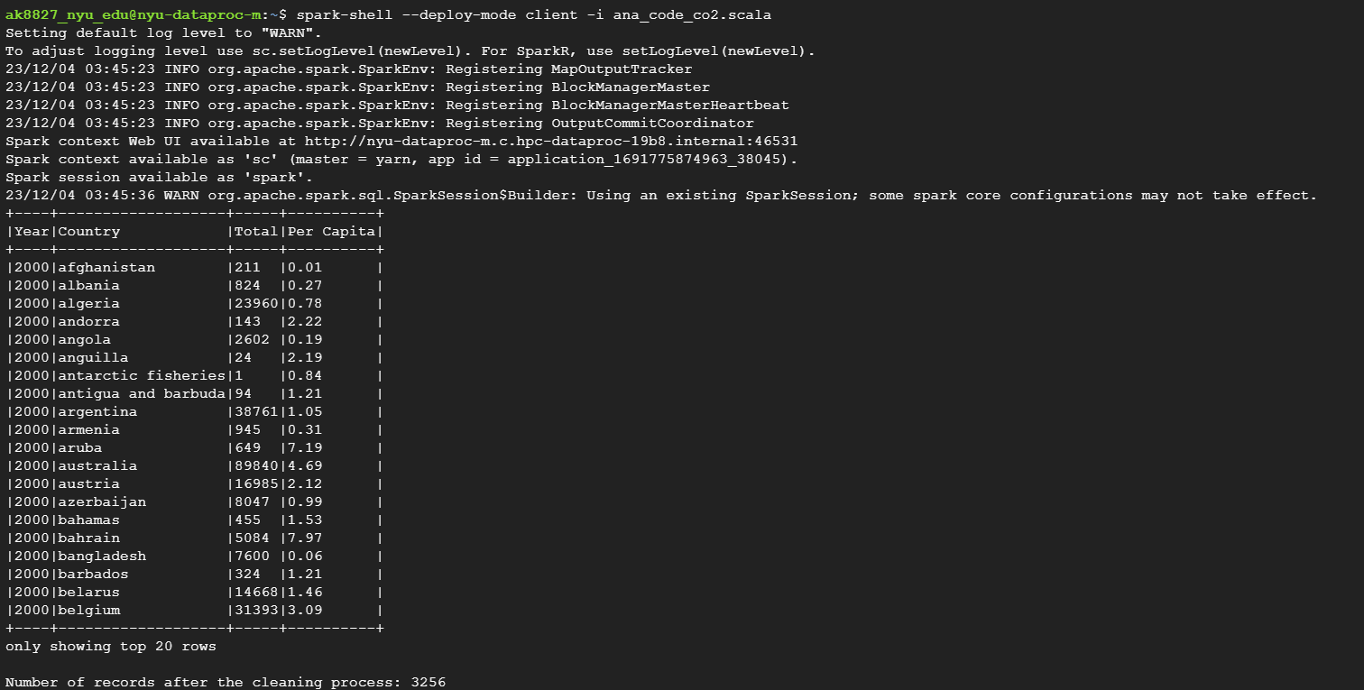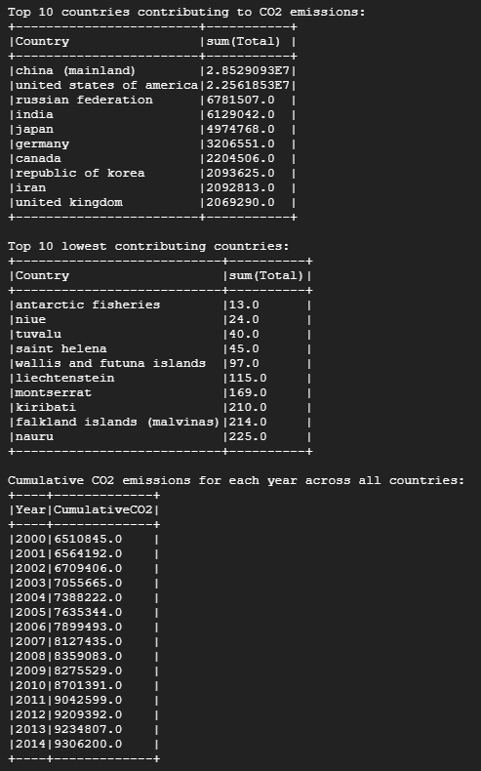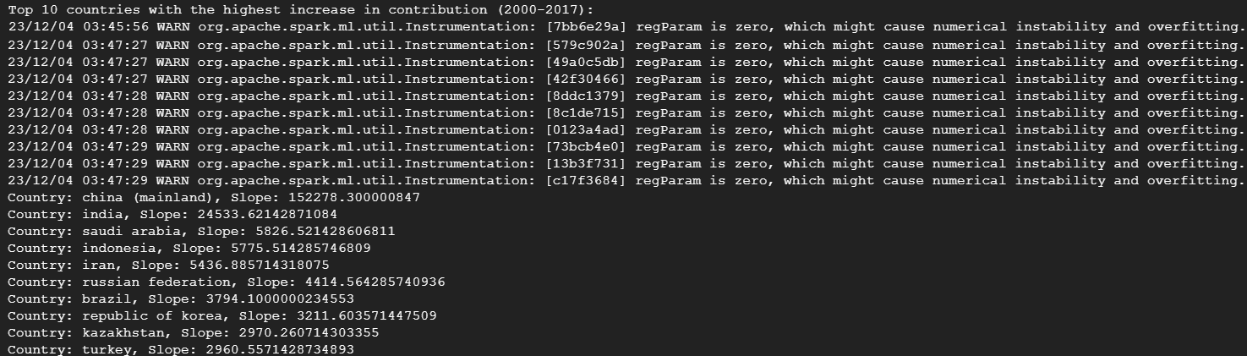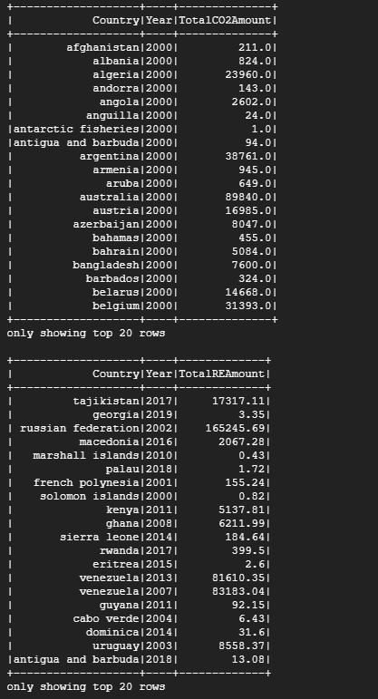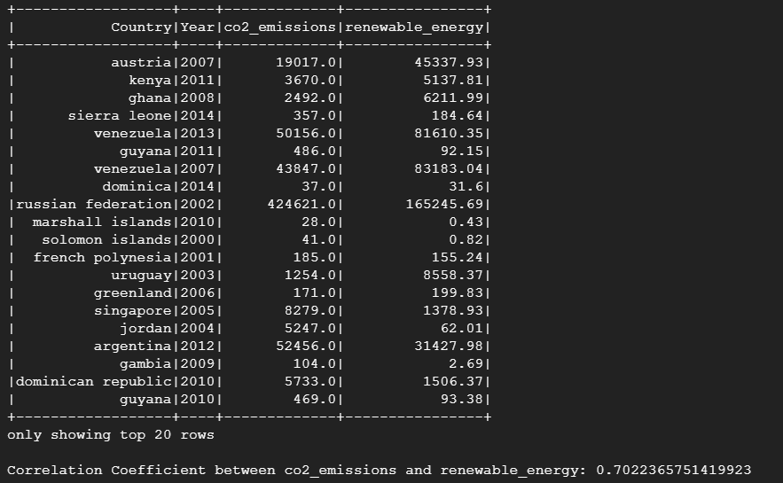

**Renewable Energy Generation Data Aibar(at4888)**

1. Dataset loading and profiling

The dataset was first loaded from the HDFS using Scala and profiled to identify basic structure, schema, sample data, summary statistics, null and distinct values. As a result of profiling the data, certain problems were identified, which were then tackled at the cleaning stage later.

1. Data Cleaning

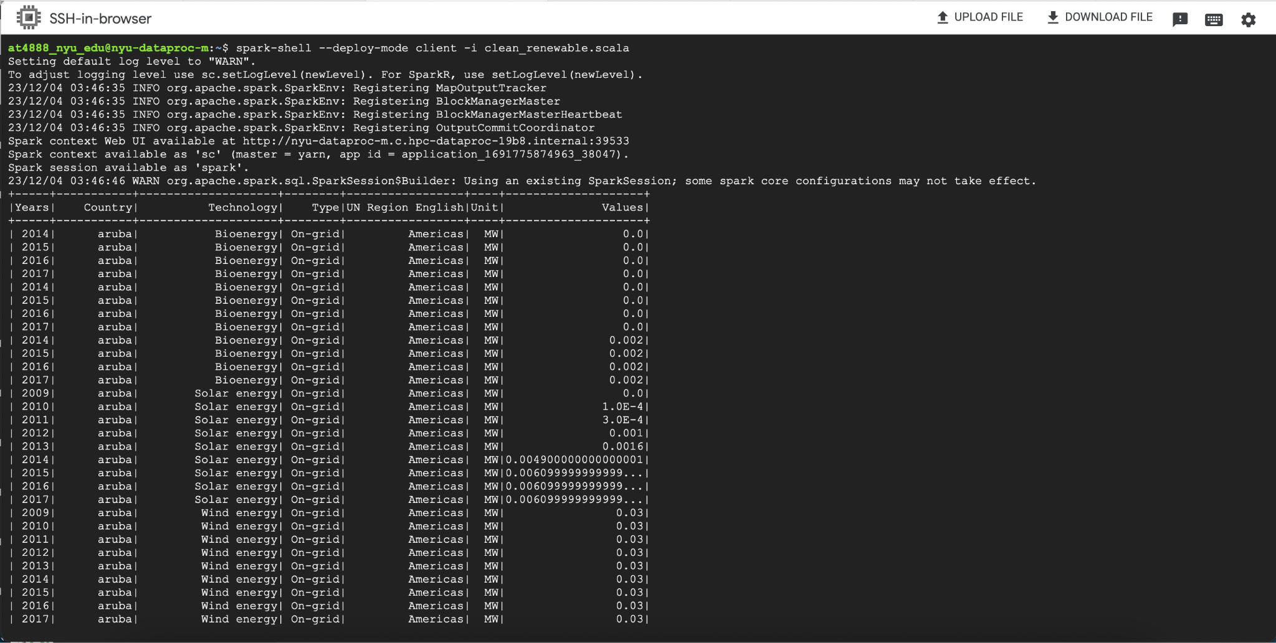

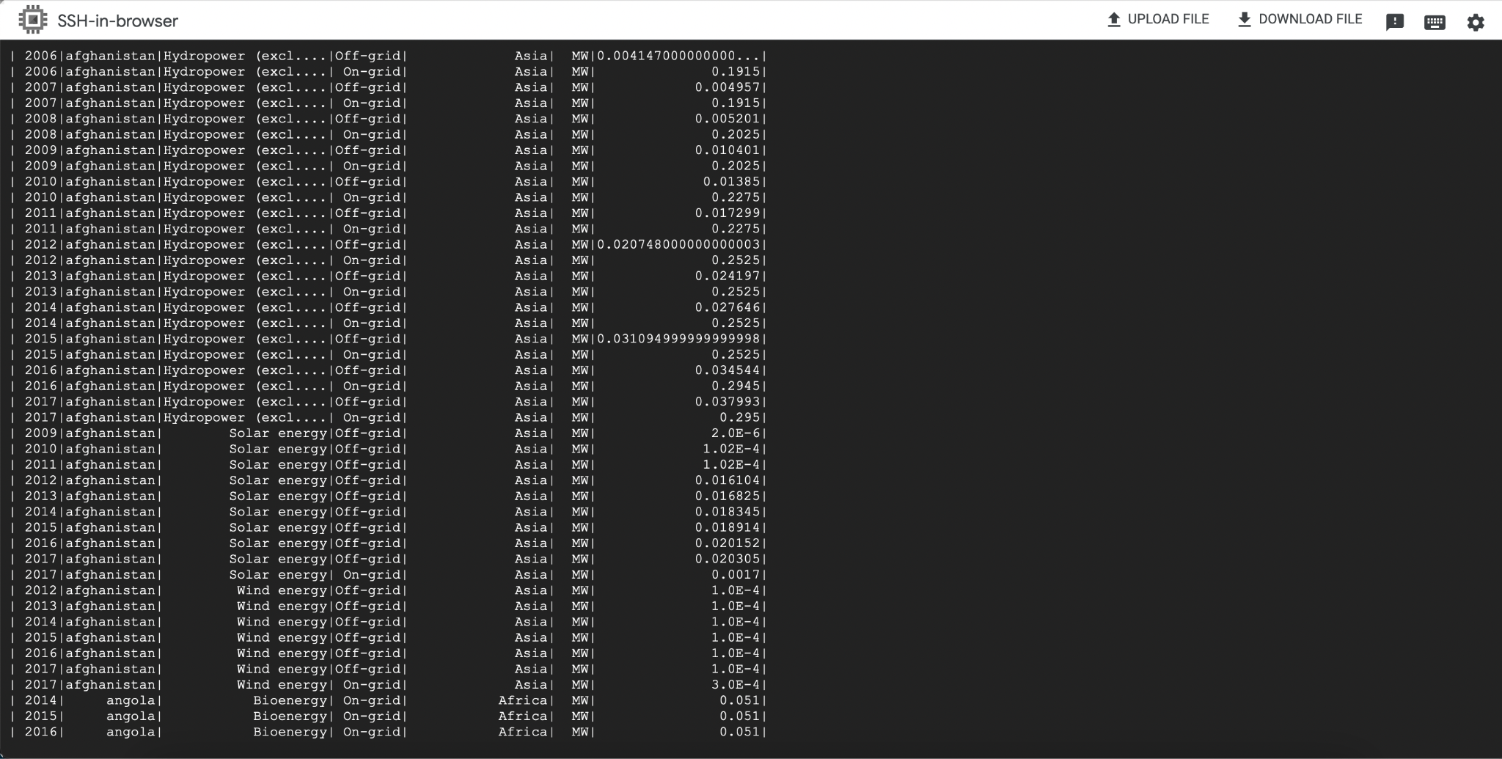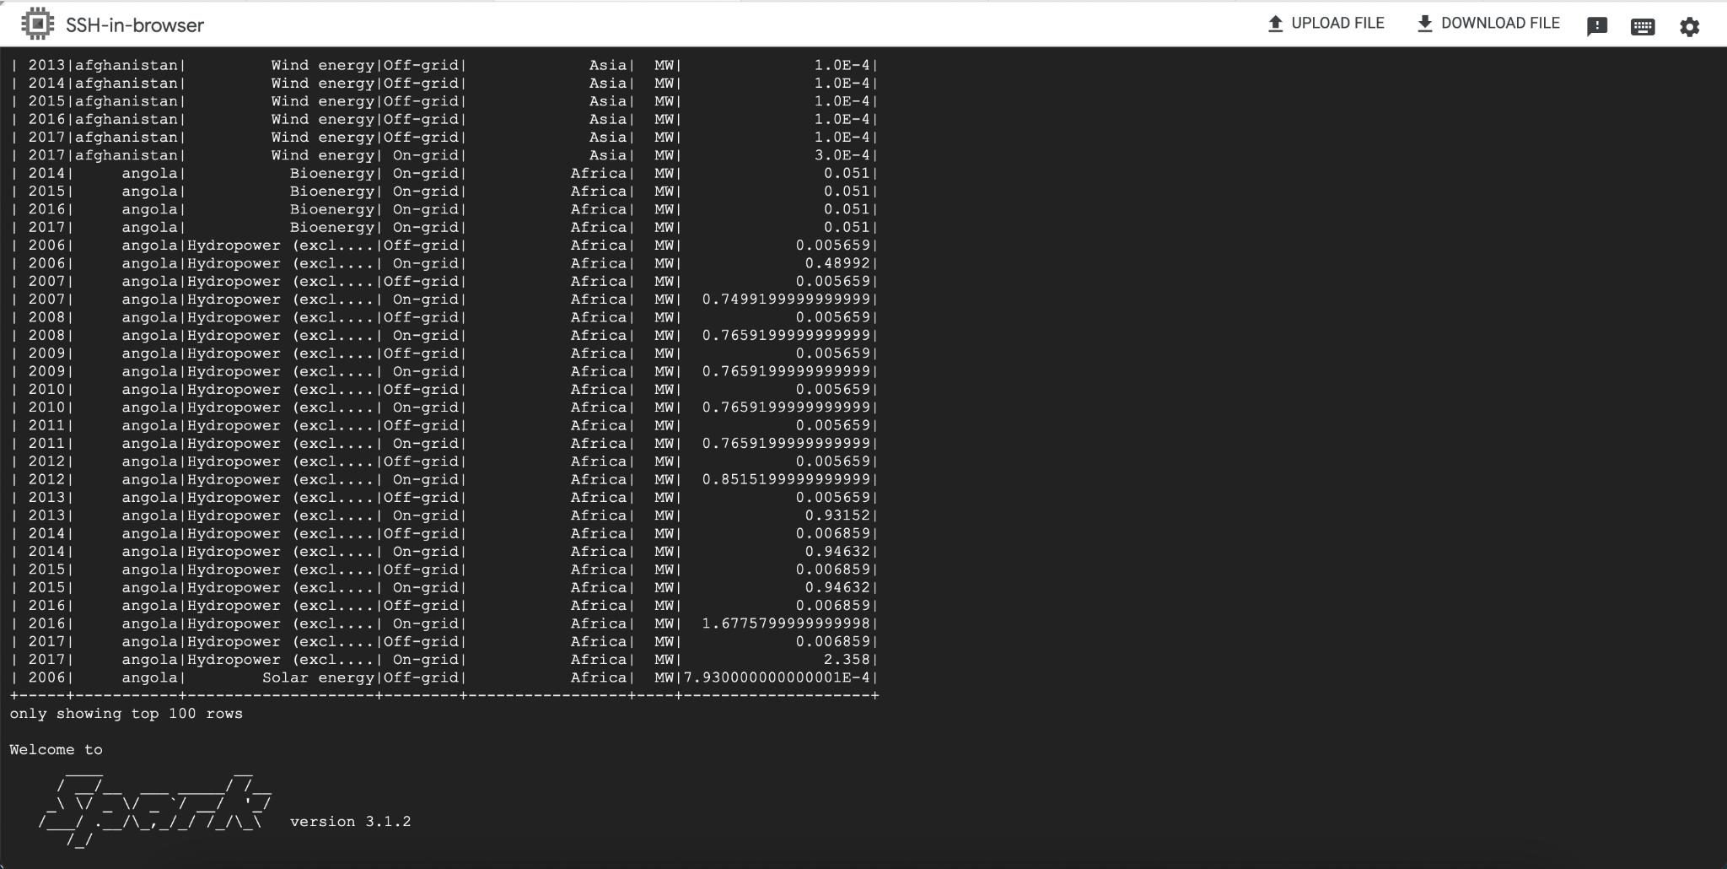

1. Analytics:
2. Aggregate renewable_generated values by country and years
3. Trends in Renewable Energy Generation by UN Region over time
4. Renewable Energy Generation by Type, On-grid or Off-grid.
5. Analyze the distribution of renewable energy generation and investments across different countries.
6. Linear regression analytics model for Investment Impact Prediction using SparkML, Root Mean Squared Error (RMSE) on test data
7. Finding top 10 countries by maximum RE generation
8. How long does it take for an investment to take effect on renewable energy generation? We tried to test it for the future 5 years after the investment was made.
9. Trends in energy generation by Technology categories over time

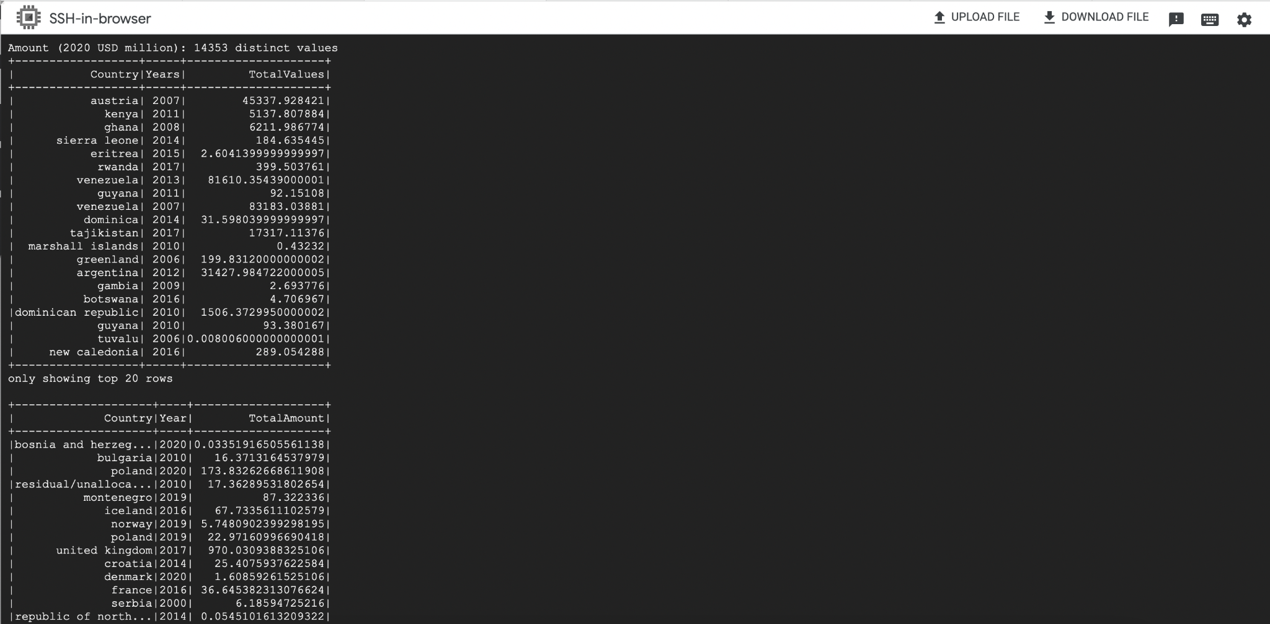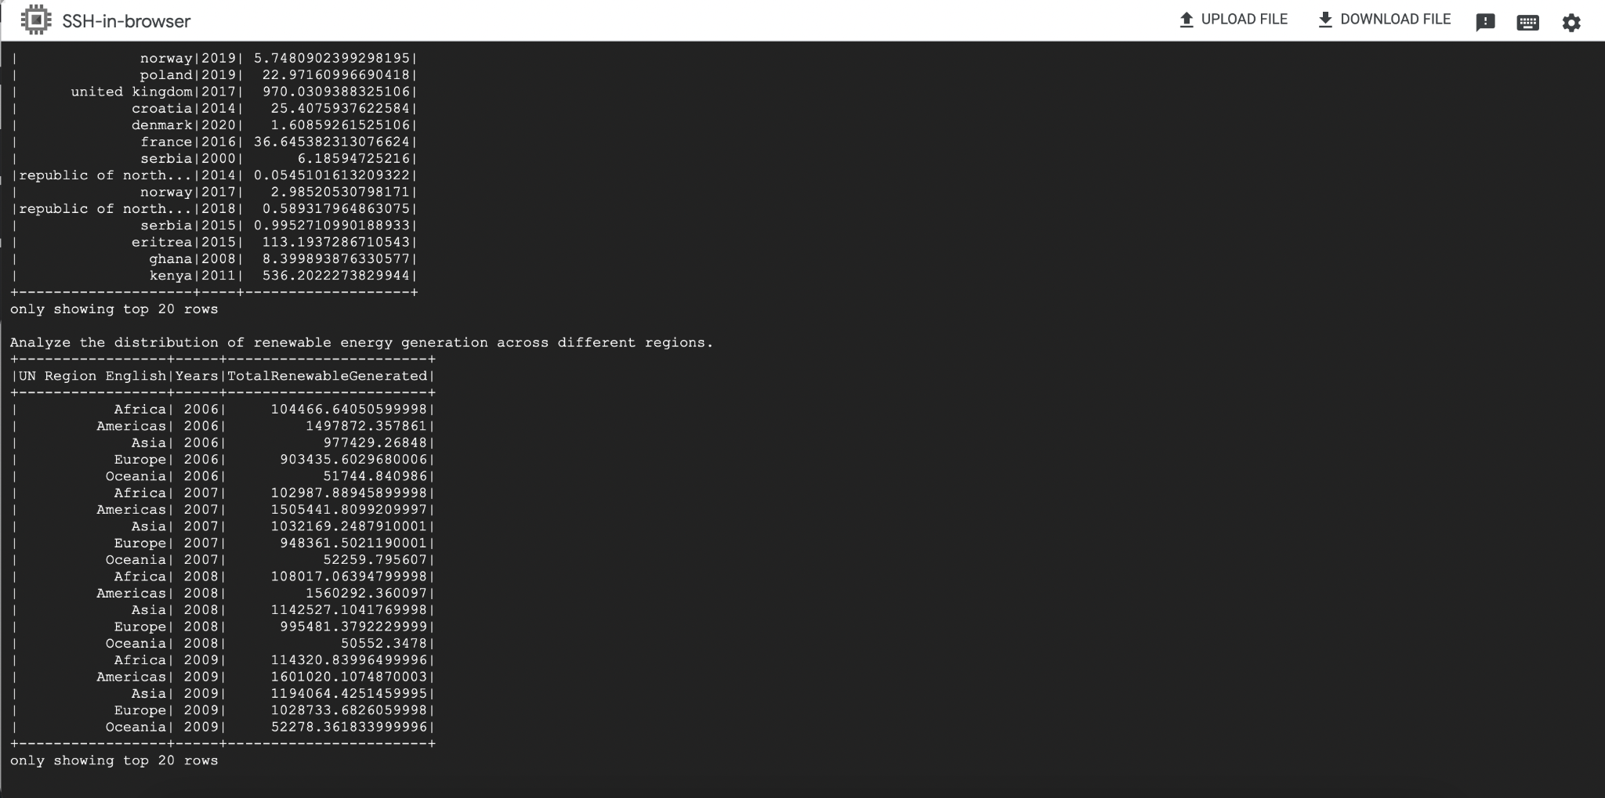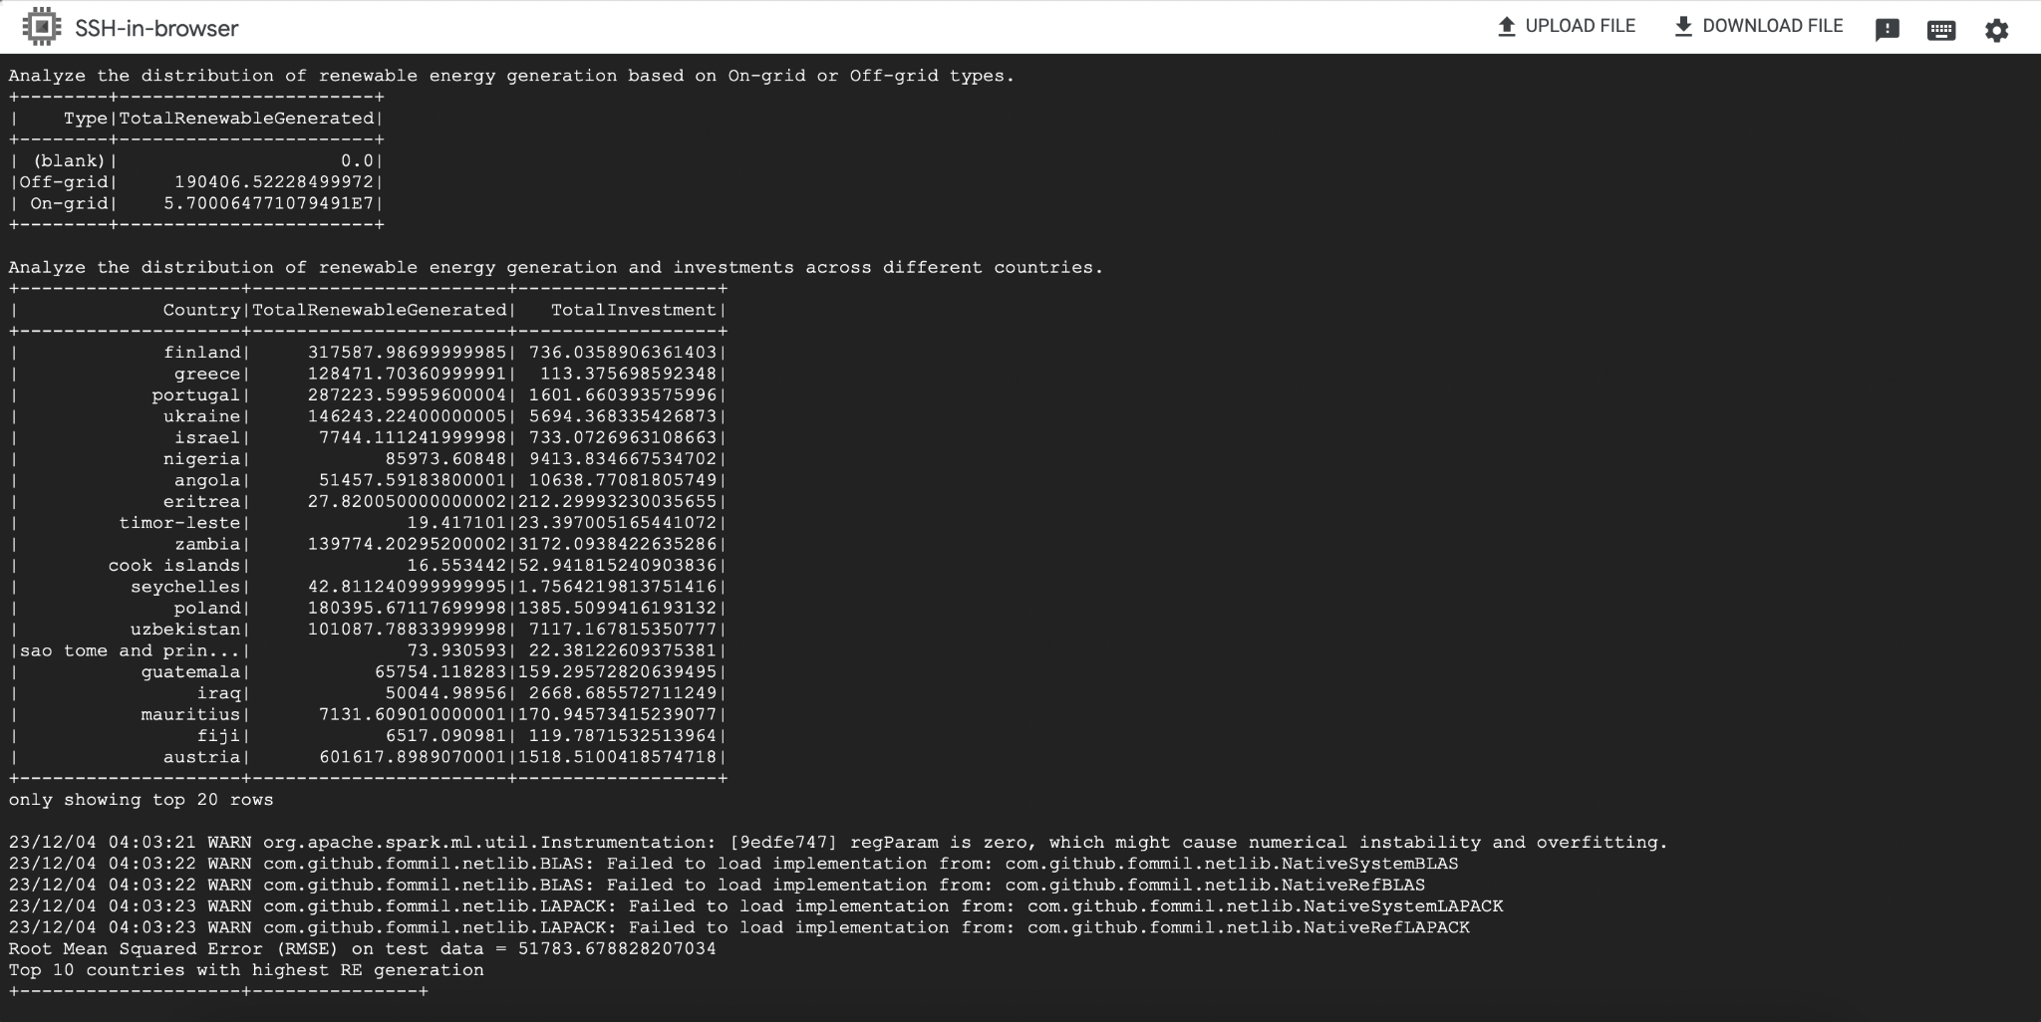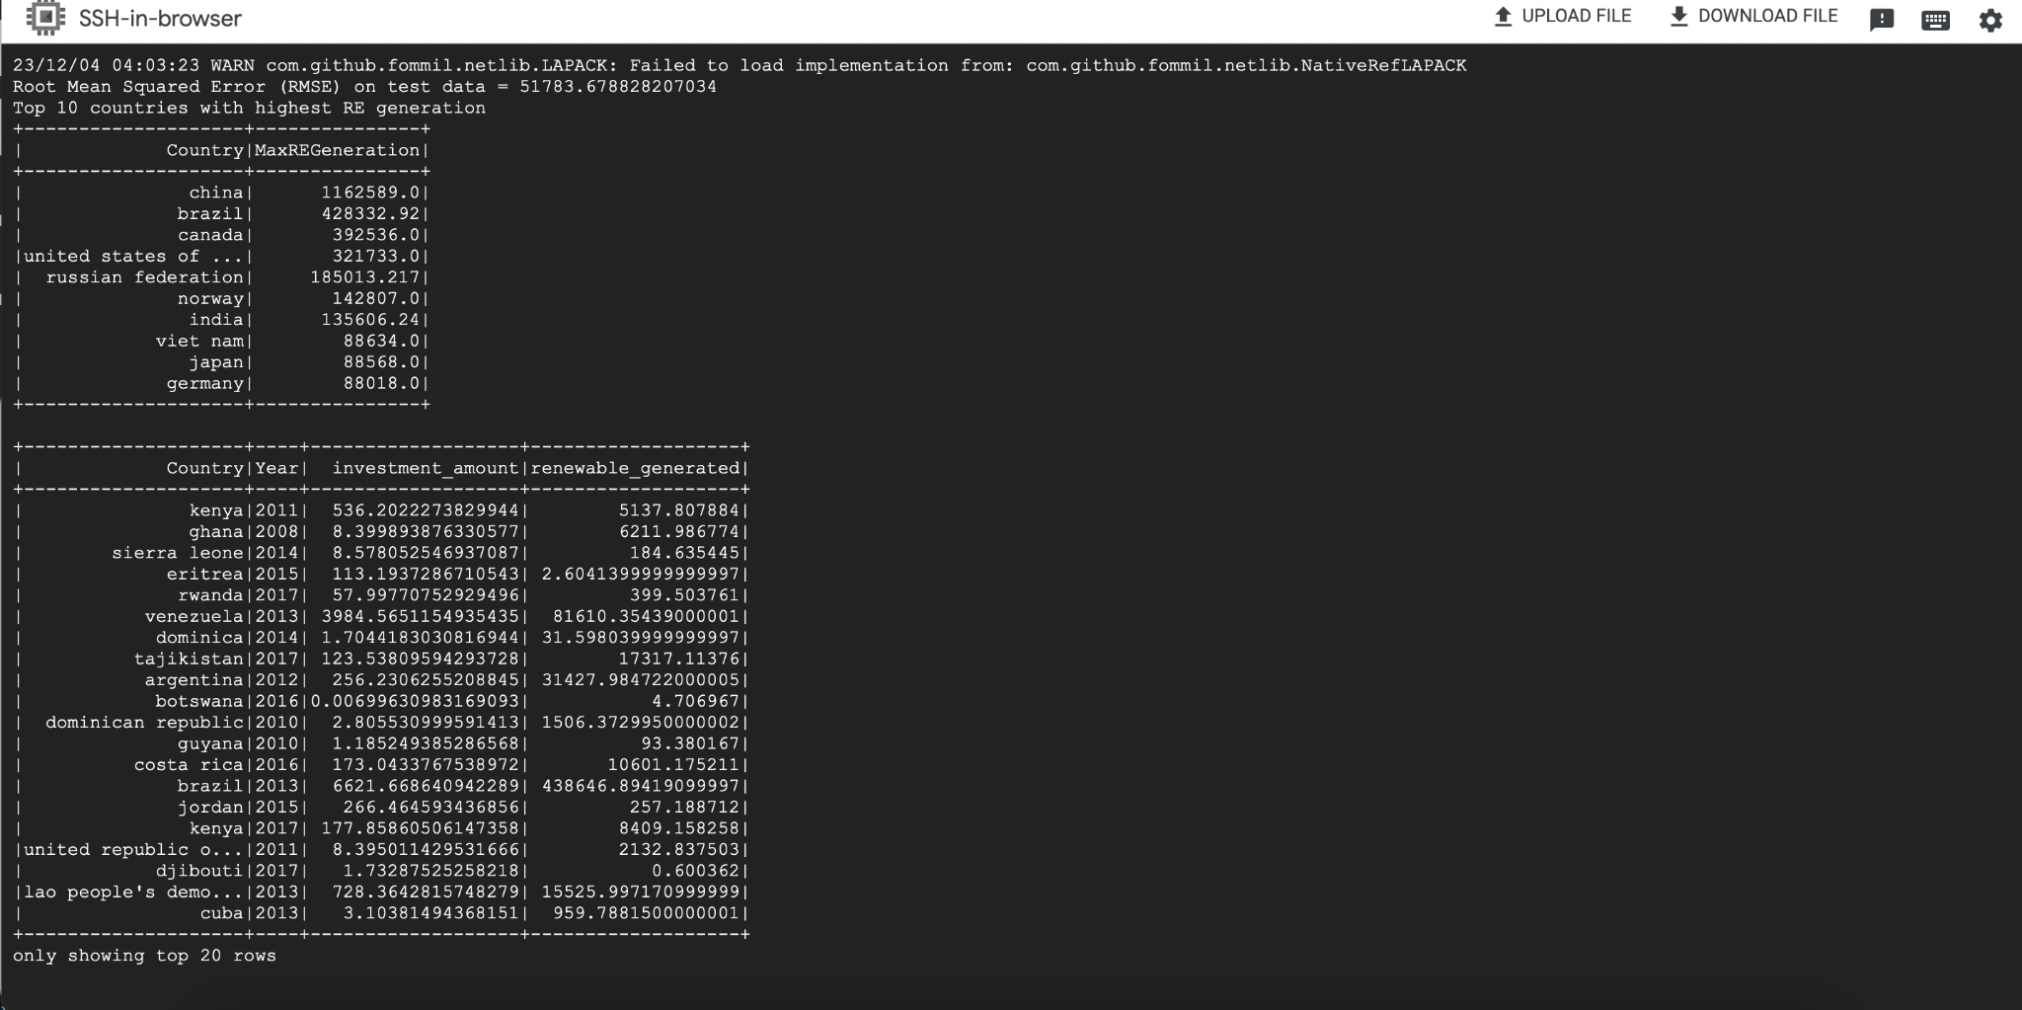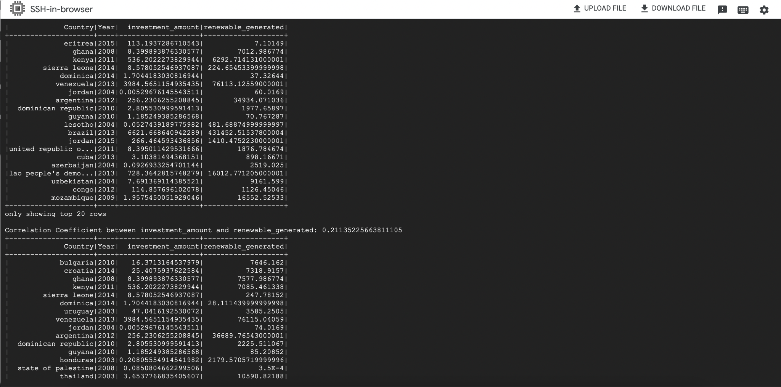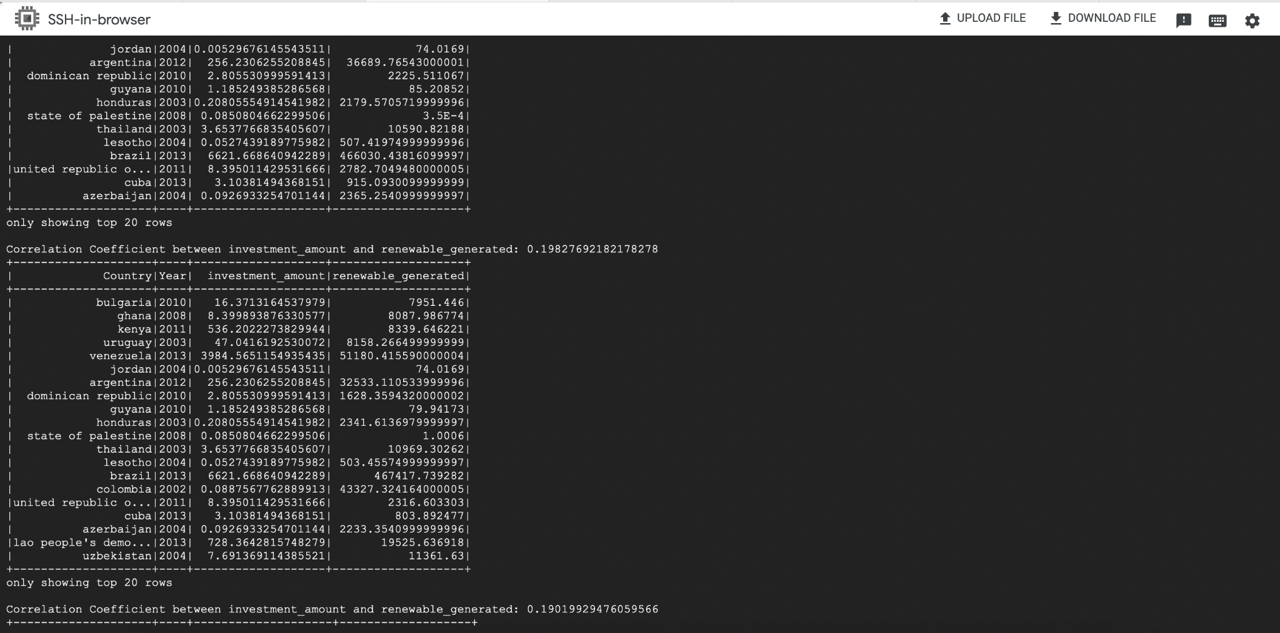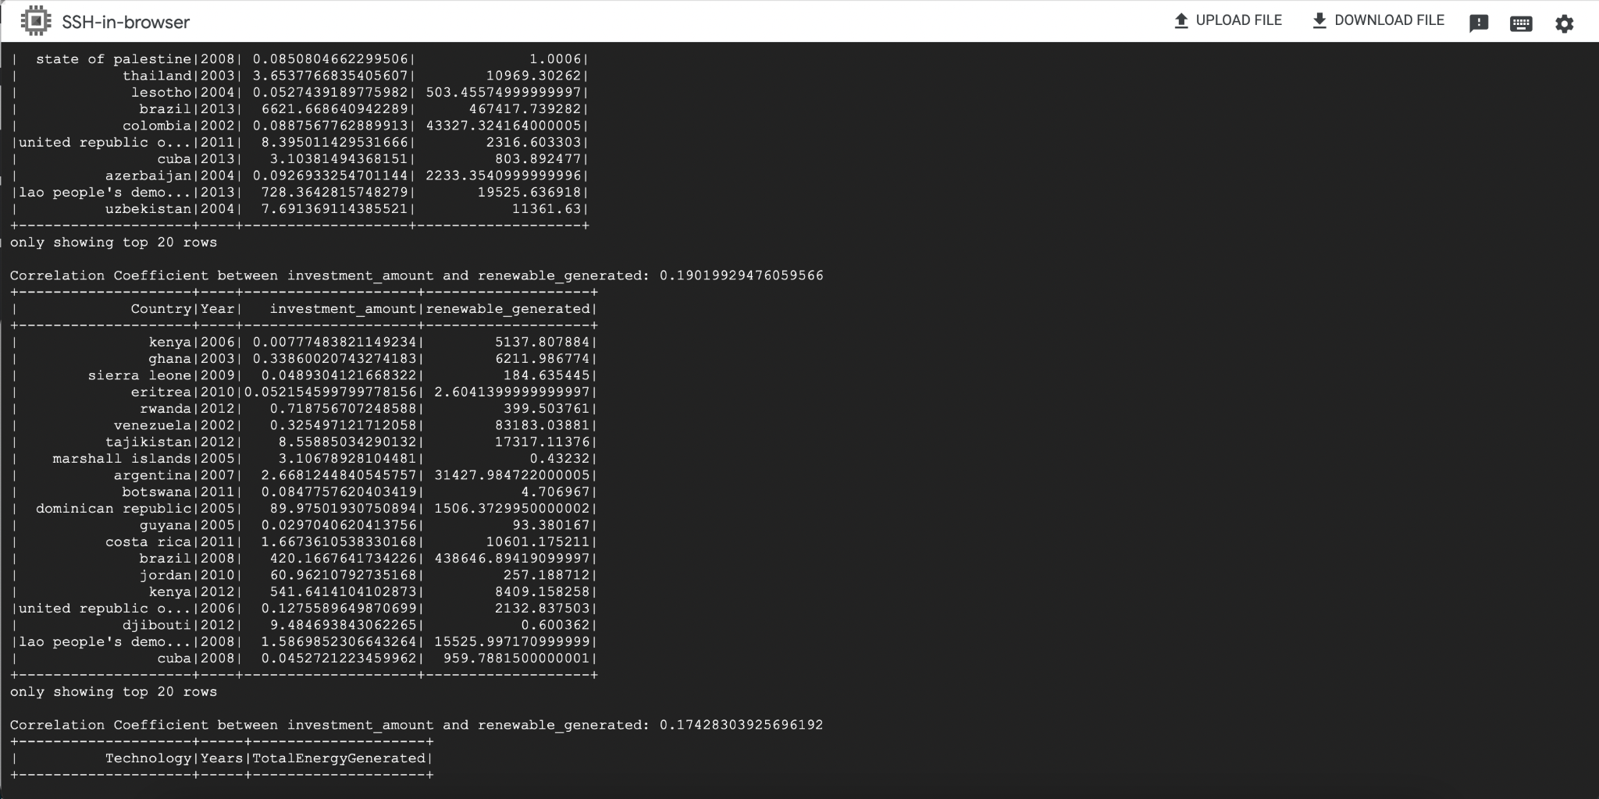

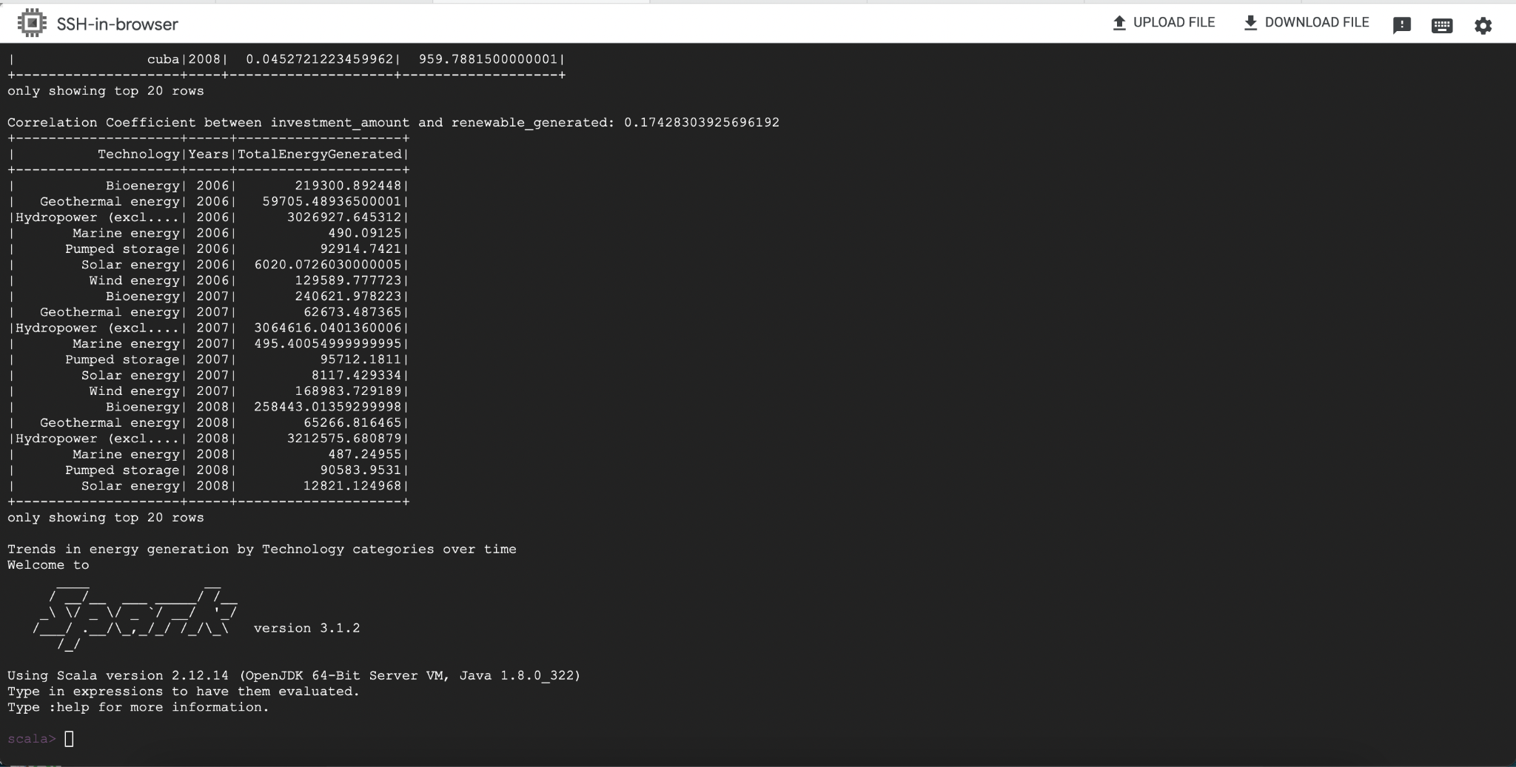

The running of Correlation between REInvestment and CO2 Emissions analytic.

**Profiling part:**

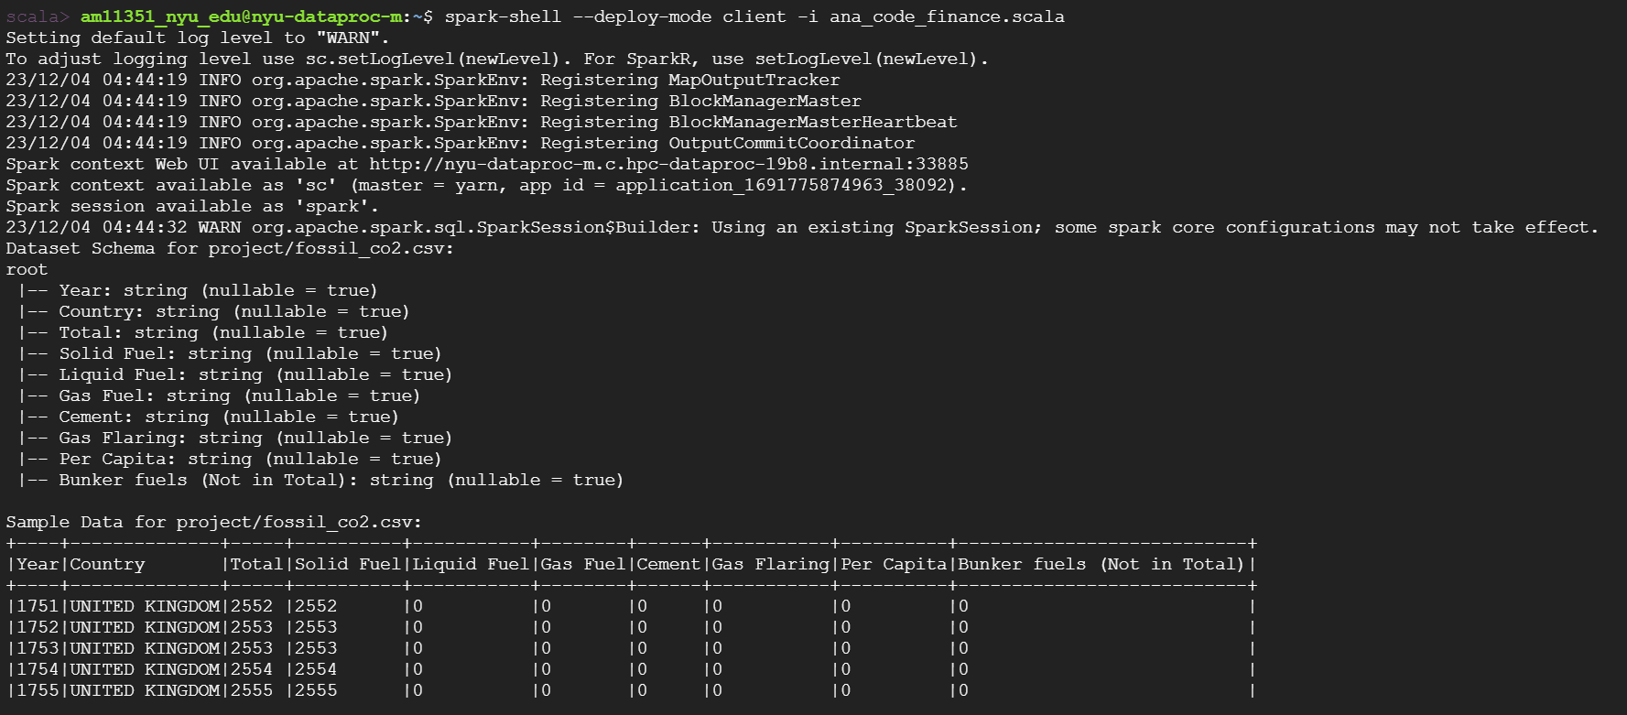

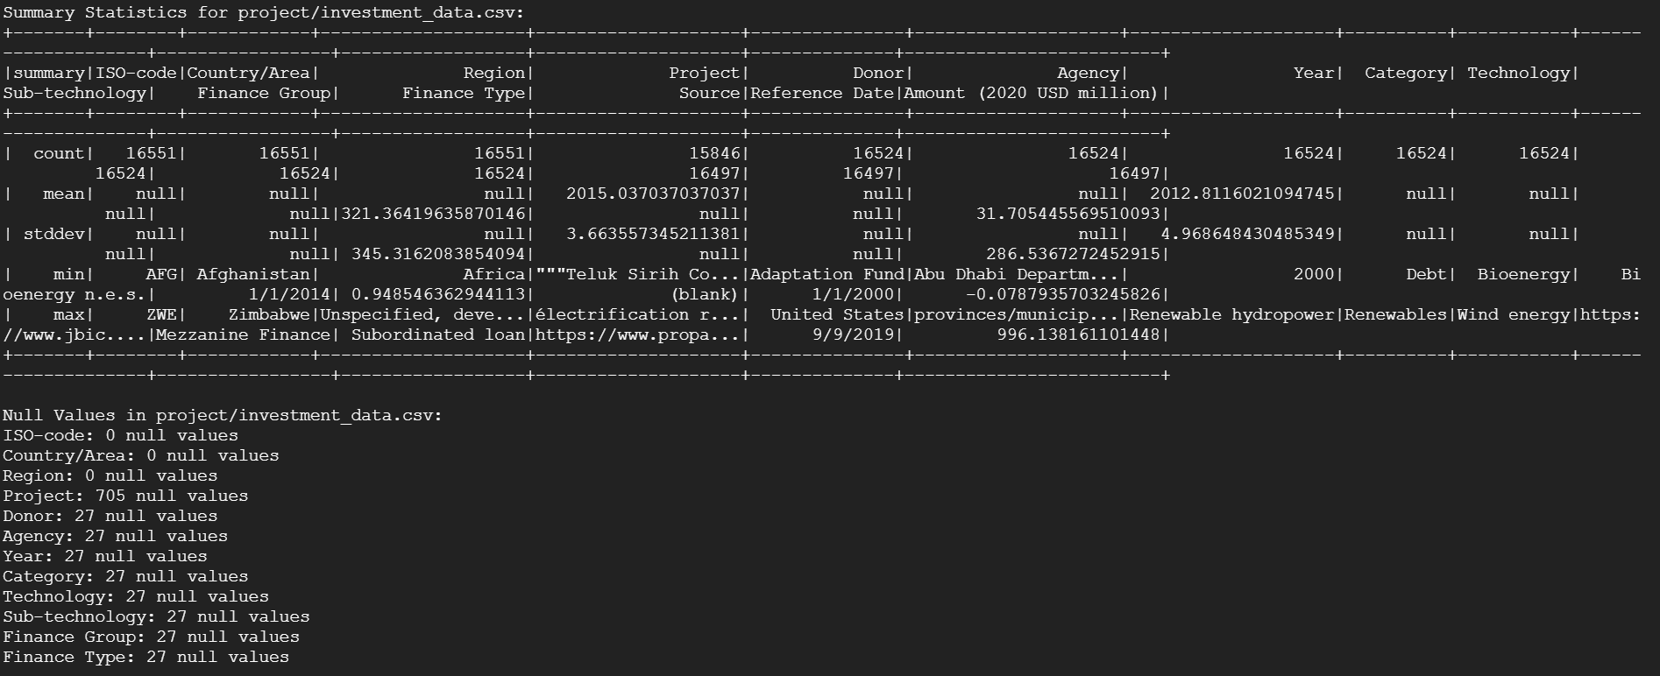

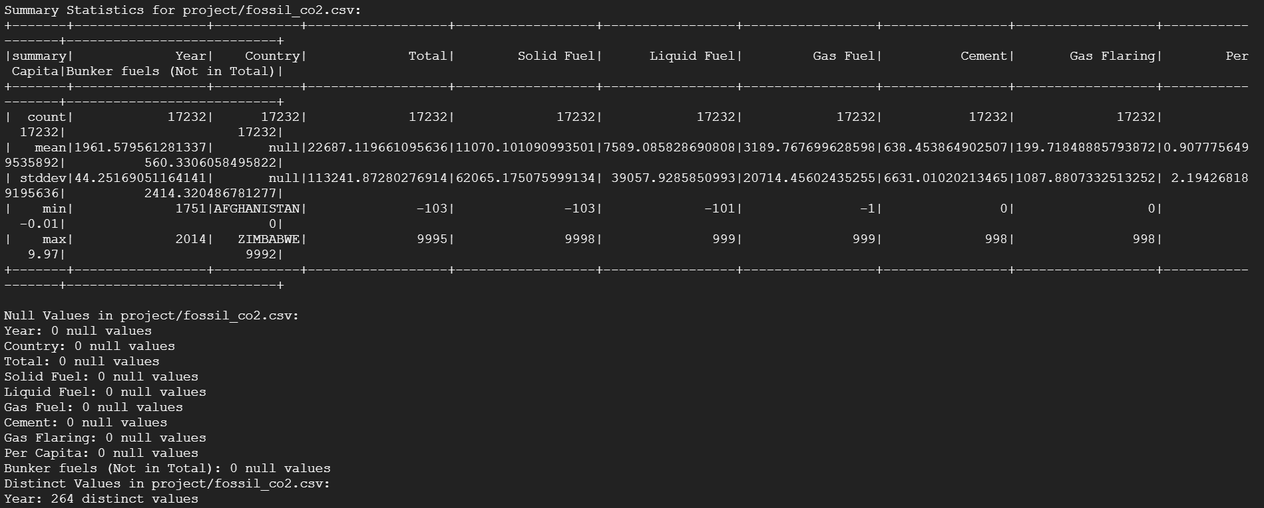

**Analytic calculation part:**

There are six description tables and correlation values shown. Each table shows the correlation between investment of X year and CO2 emission of X+i year to see the short-term and long-term effect of REInvestments.

